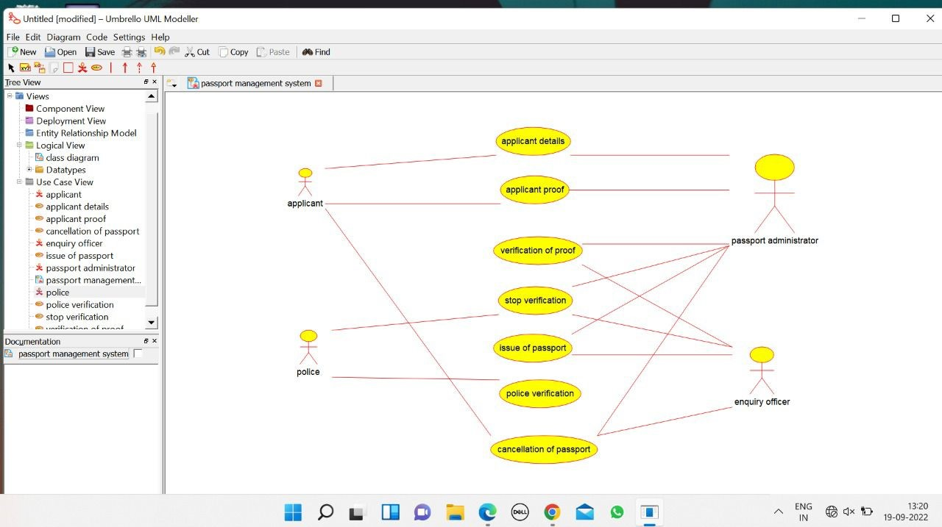

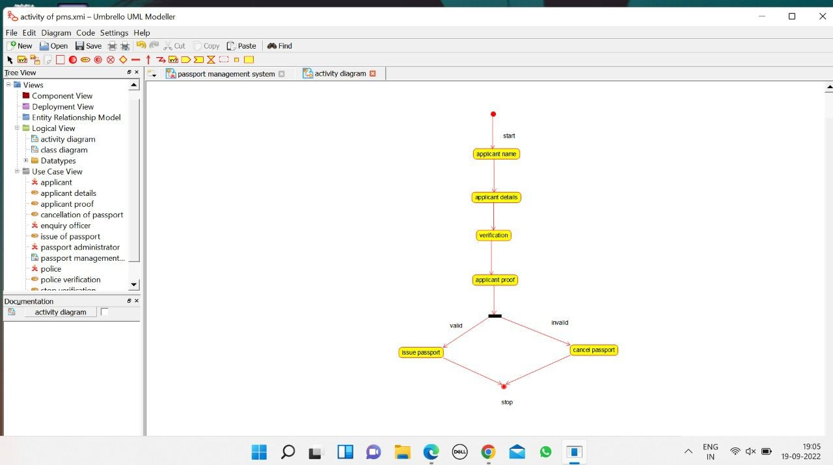

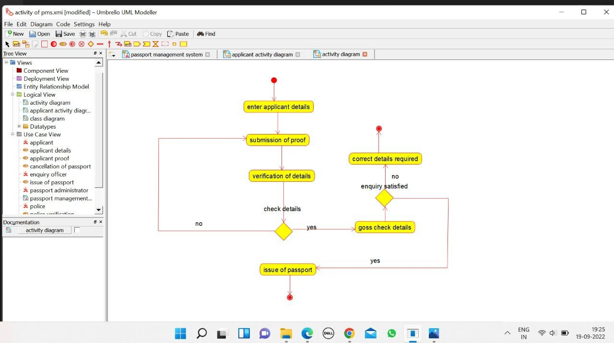

class diagram of pmsxmi — Umbrello UML Modeller

1928

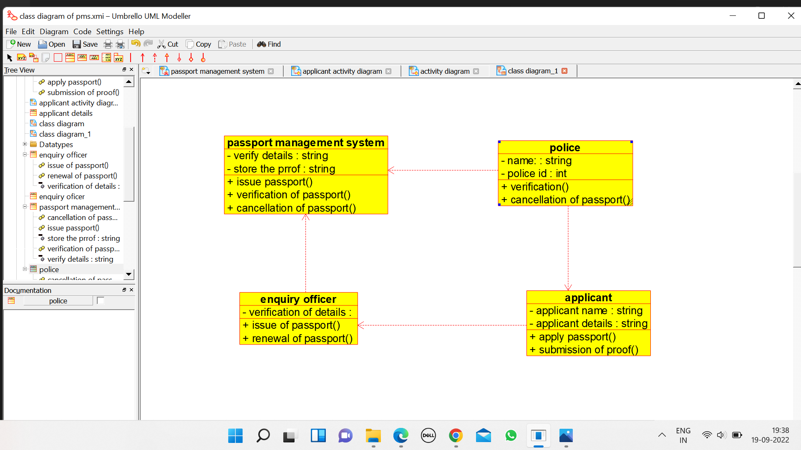

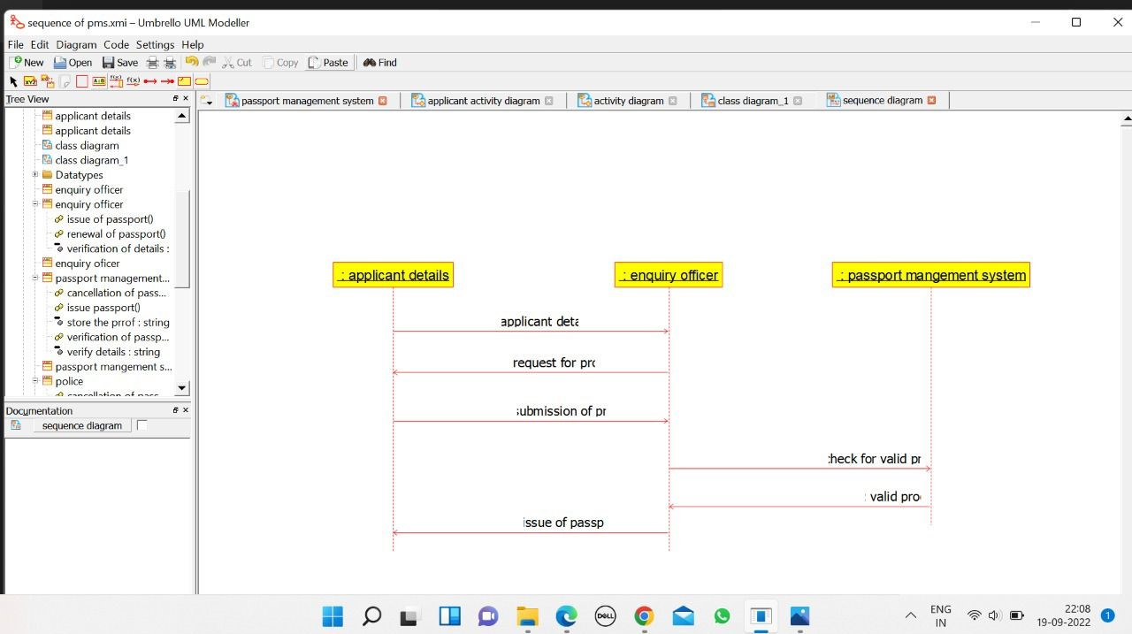

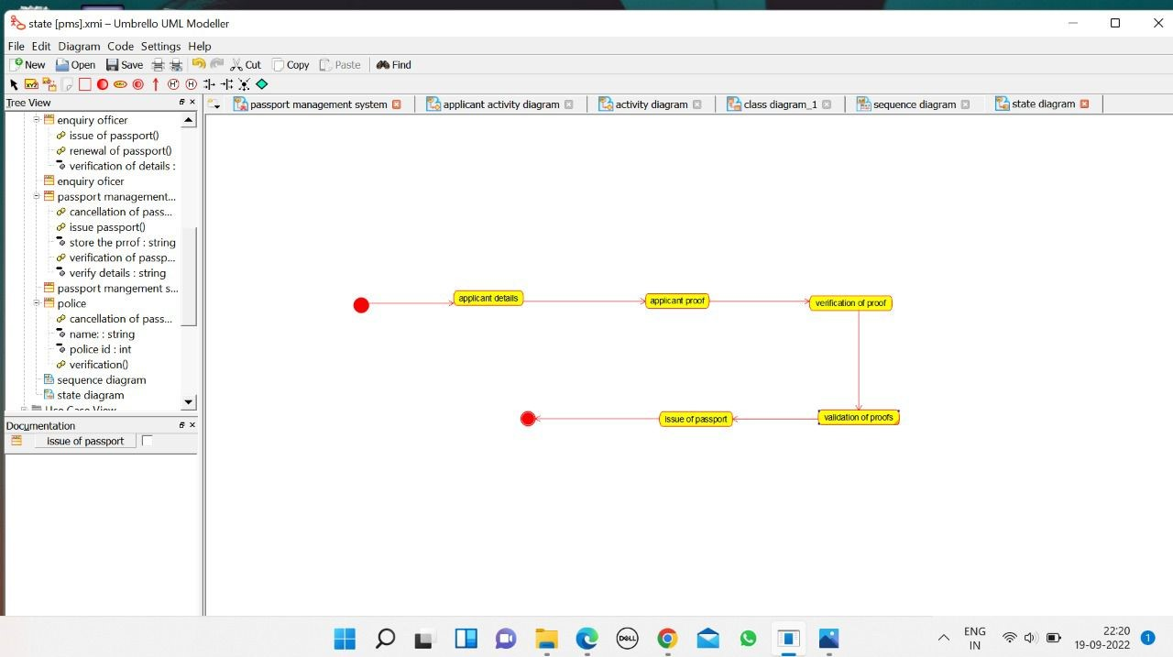

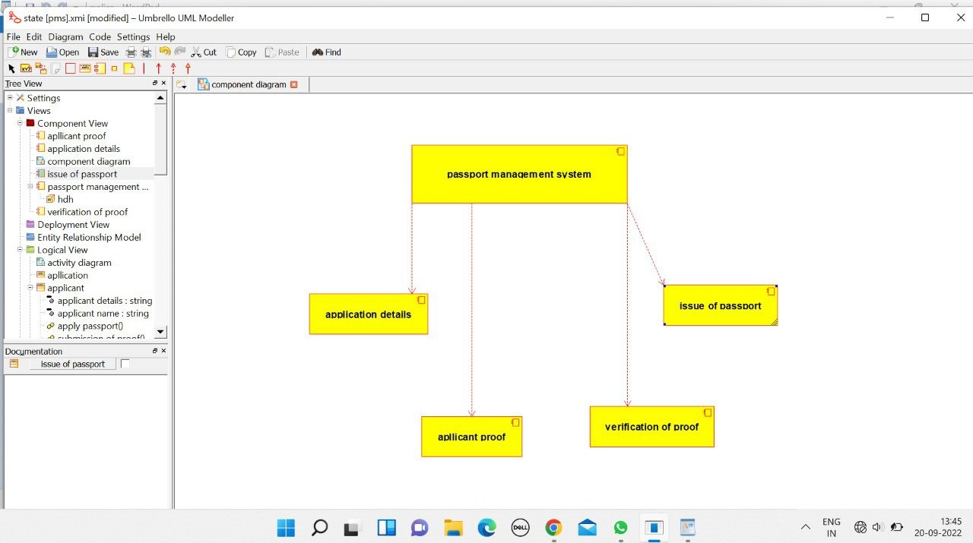

APPLICANT:

/**

* Class applicant

*/

public class applicant {

//

// Fields

//

private String applicant_name;

private String applicant_details;

//

// Constructors

//

public applicant () { };

//

// Methods

//

//

// Accessor methods

//

/**

* Set the value of applicant_name

* @param newVar the new value of applicant_name

*/

private void setApplicant_name (String newVar) {

applicant_name = newVar;

}

/**

* Get the value of applicant_name

* @return the value of applicant_name

*/

private String getApplicant_name () {

return applicant_name;

}

/**

* Set the value of applicant_details

* @param newVar the new value of applicant_details

*/

private void setApplicant_details (String newVar) {

applicant_details = newVar;

}

/**

* Get the value of applicant_details

* @return the value of applicant_details

*/

private String getApplicant_details () {

return applicant_details;

}

//

// Other methods

//

/**

*/

public void apply_passport()

{

}

/**

*/

public void submission_of_proof()

{

}

}

APPLICANT DETAILS:

/**

* Class applicant_details

*/

public class applicant_details {

//

// Fields

//

//

// Constructors

//

public applicant_details () { };

//

// Methods

//

//

// Accessor methods

//

//

// Other methods

//

}

ENQUIRY OFFICER:

/**

* Class enquiry_officer

*/

public class enquiry_officer {

//

// Fields

//

private void verification_of_details;

//

// Constructors

//

public enquiry_officer () { };

//

// Methods

//

//

// Accessor methods

//

/**

* Set the value of verification_of_details

* @param newVar the new value of verification_of_details

*/

private void setVerification_of_details (void newVar) {

verification_of_details = newVar;

}

/**

* Get the value of verification_of_details

* @return the value of verification_of_details

*/

private void getVerification_of_details () {

return verification_of_details;

}

//

// Other methods

//

/**

*/

public void issue_of_passport()

{

}

/**

*/

public void renewal_of_passport()

{

}

}

NEW CLASS:

/**

* Class new_class

*/

public class new_class {

//

// Fields

//

//

// Constructors

//

public new_class () { };

//

// Methods

//

//

// Accessor methods

//

//

// Other methods

//

}

NEW CLASS 1:

/**

* Class new_class_1

*/

public class new_class_1 {

//

// Fields

//

//

// Constructors

//

public new_class_1 () { };

//

// Methods

//

//

// Accessor methods

//

//

// Other methods

//

}

PASSPORT MANAGEMENT SYSTEM:

/**

* Class passport_mangement_system

*/

public class passport_mangement_system {

//

// Fields

//

//

// Constructors

//

public passport_mangement_system () { };

//

// Methods

//

//

// Accessor methods

//

//

// Other methods

//

}

POLICE

/**

* Class police

*/

public class police {

//

// Fields

//

private String name_;

private int police_id;

//

// Constructors

//

public police () { };

//

// Methods

//

//

// Accessor methods

//

/**

* Set the value of name_

* @param newVar the new value of name_

*/

private void setName_ (String newVar) {

name_ = newVar;

}

/**

* Get the value of name_

* @return the value of name_

*/

private String getName_ () {

return name_;

}

/**

* Set the value of police_id

* @param newVar the new value of police_id

*/

private void setPolice_id (int newVar) {

police_id = newVar;

}

/**

* Get the value of police_id

* @return the value of police_id

*/

private int getPolice_id () {

return police_id;

}

//

// Other methods

//

/**

*/

public void verification()

{

}

/**

*/

public void cancellation_of_passport()

{

}

}

